NOTICE
Counselling for Admission to the LL.B. Programme
(Academic Session 2026–27)
Date: 10 August 2026
All candidates who appeared in the University Entrance Test (UET) for admission to LL.B. Program held in June 2026 and who have paid and registered themselves on the SAMARTH Portal for admission to the Department of Law, SRT Campus, Tehri Garhwal, are hereby informed that counselling for admission to the LL.B. Programme will be held as per the following schedule:
Date of Counselling | 17 August 2026
Reporting Time | 10:00 a.m.
Venue | Department of Law, SRT Campus, Badshahi Thaul, Tehri Garhwal

Only those candidates who report for counselling will be considered for admission. Appearance at the counselling does not guarantee admission to the LL.B. Programme. No TA/DA will be paid for attending the counselling.
Candidates must mandatorily bring the following original documents along with a complete set of self-attested photocopies:
- High School Marksheet & Certificate (as proof of Date of Birth);
- Intermediate Marksheet;
- Graduation Marksheet (candidates must have secured more than 45%, 42% and 40% for UR, OBC and SC & ST respectively in their graduation);
- Transfer Certificate / Migration Certificate, Character Certificate, and Gap Certificate (if applicable);
- Category Certificate(s): SC / ST / OBC (in the Government of India format for the preceding financial year), EWS (latest), and NCC / NSS / Sports certificates (if applicable). The OBC and EWS certificates must have been issued after 31 March 2026 and must be in the prescribed Central Government format;
- NCC/NSS/ Sports/ Extra-Curricular Activities Certificates (if claiming weightage);
- One printed copy of the online application form generated through the SAMARTH Portal; and
- UET Score Card.
Candidates are advised to carefully verify their eligibility before appearing for counselling. In view of the prevailing weather conditions in the State, candidates are strongly advised to reach the campus one day prior to the date of counselling.
For any clarification, candidates may contact the Convenor or the Member of the Admission Committee for LL.B. First Semester, whose details are given below.

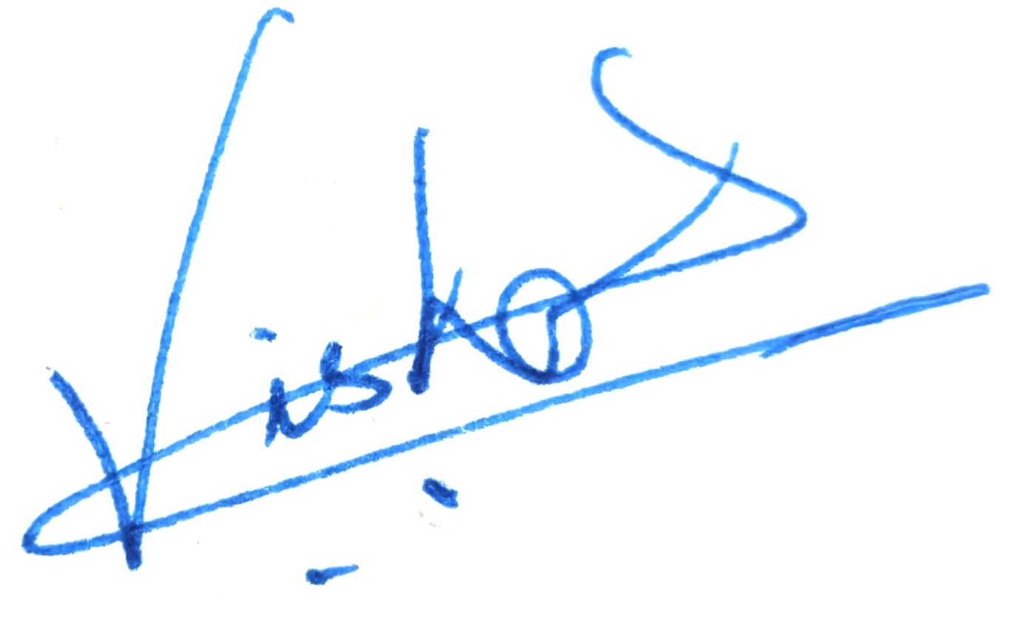
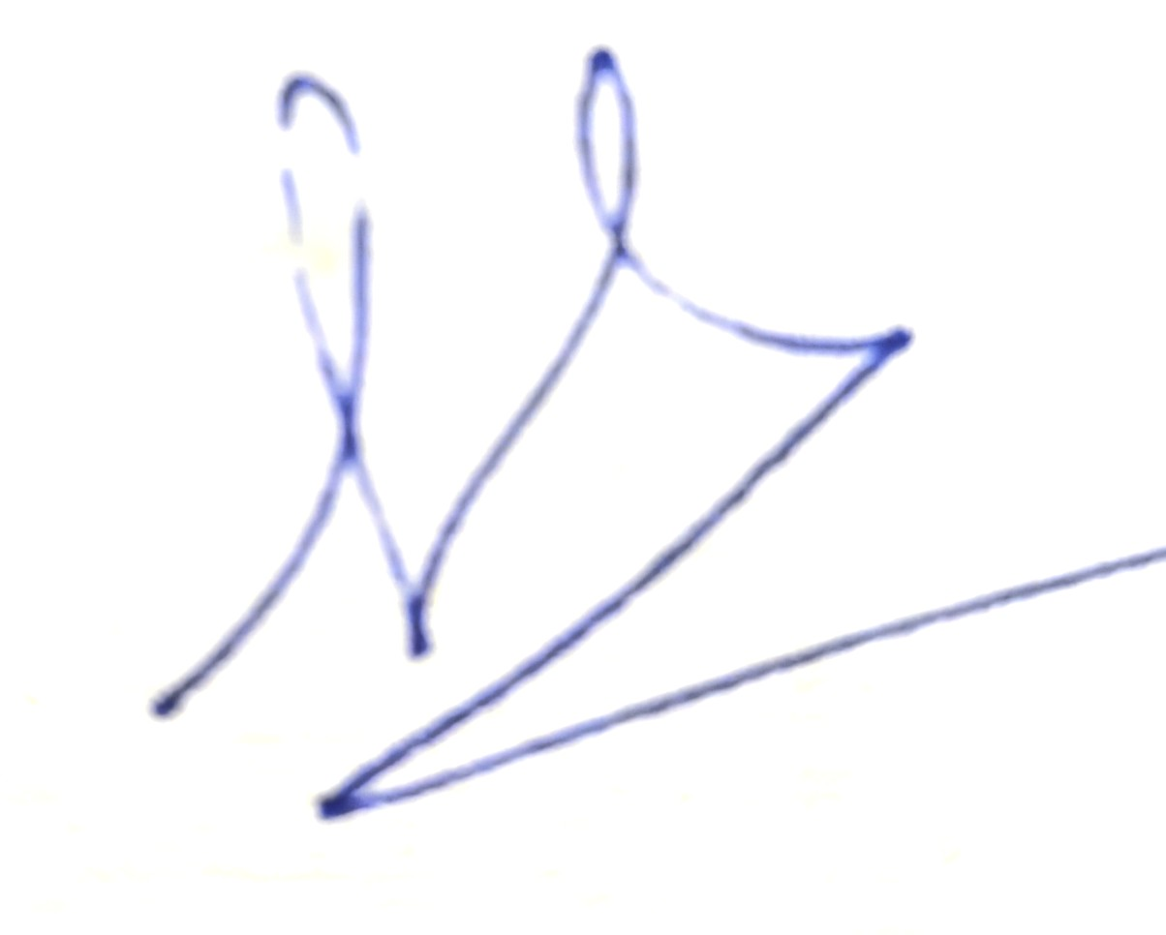

Convenor Member
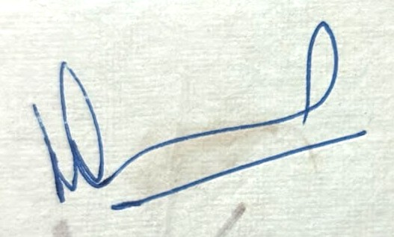

Dr. S.K. Chaturvedi Dr. Vishal Guleria
Mobile: 8765109702 Mobile: 9760417900
Head
Department of Law
SRT Campus, Badshahi Thaul

