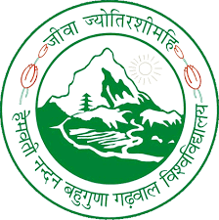
DEPARTMENT OF FORESTRY AND NATURAL RESOURCES
HNB Garhwal University (A Central University)
Srinagar Garhwal

Walk in Interview
(On 31 January 2023 at 11.00 am)
Venue: Department of Forestry and Natural Resources,
HNB Garhwal University (A Central University), Srinagar Garhwal

Applications are invited for the position of Project Assistant under NIF (National Innovation Foundation) sponsored project entitled “Scouting and Documentation of Grassroots Innovations, Traditional Knowledge and Innovative practices from District Chamoli of Uttarakhand” to be implemented in the Department of Forestry and Natural Resources, Chauras campus of the University for a period of 01 year.
Sr. No. | Position | Emoluments (Rs.) | Minimum Qualification | Desirable Experience
1. | Project Assistant | 20000/- fixed per month + 9% HRA | MSc. in Forestry/ MAPs/ Horticulture/ Botany/ rural technology/Agriculture | Experience in Documentation/Field work with Rural communities

Terms & Conditions: -
- The appointments are purely temporary and on project basis.
- The appointments will be initially done for a period of six months which can be extended till the completion of the project subject to the performance of the candidate.
- No TA/DA will be given to the applicants to attend the interview.
Interested candidates are required to come with a brief CV along with all supporting documents (Marksheets, Certificates, etc.). CV may be sent in advance to the Principal Investigator of the project on drbutolajs@gmail.com copy to bhhimshikha654@gmail.com

Principal Investigator of the Project
Department of Forestry and Natural Resources

